SQL commands
TO CREATE DATABASE
Create database database_name
CREATE TABLE
Create table tablename( col1
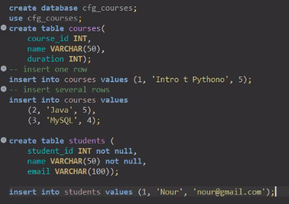

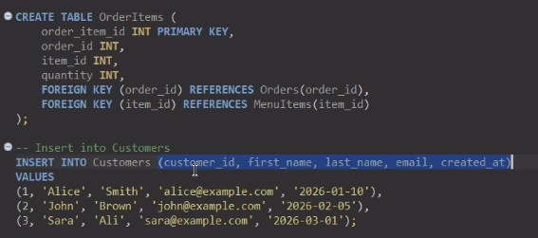

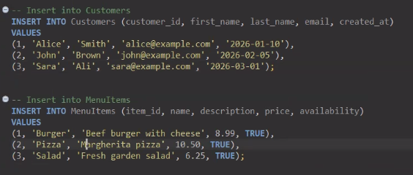

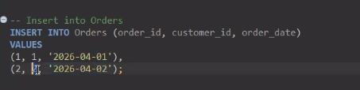

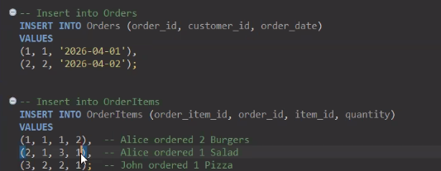

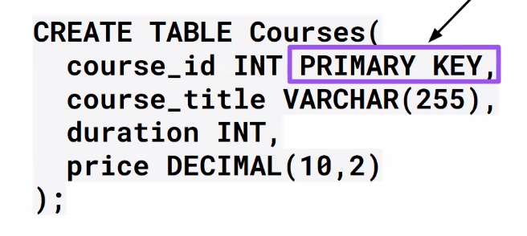

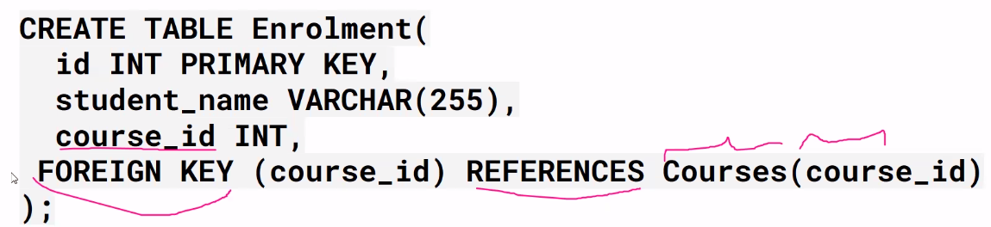

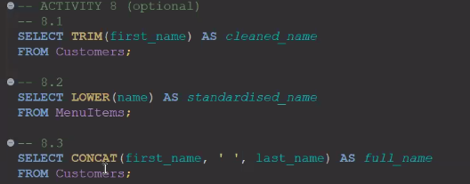

## TO KNOW COLUMN NAME IN A TABLE
DESCRIBE your_table_name;
Or
SHOW COLUMNS FROM your_table_name;
Will show the column names etc.

## TO SEE USER DETAILS IN SQL
In SQL you can run a quick command to ask the database who you are:
SELECT USER();
This will return a result name@localhost, what’s before the at symbol will be your username

## TO RUN CODE IN VSCODE
python filename.py

## TO SEE LIST OF DATABASES

Create an empty script
Type – show database

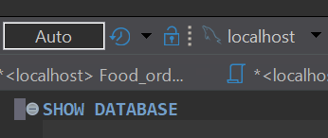
## AUTO FORMAT
Ctrl + Shift + ‘F’

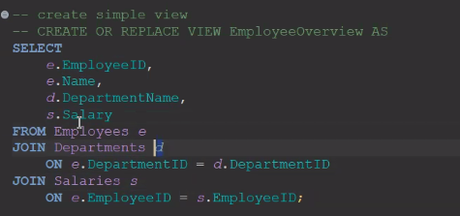

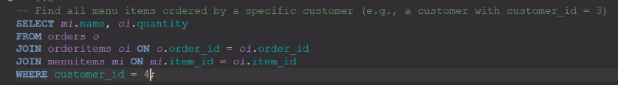

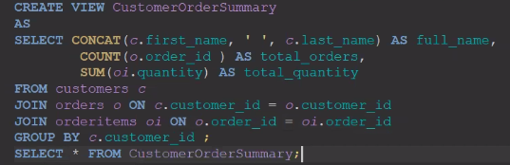
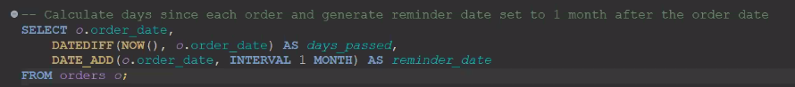

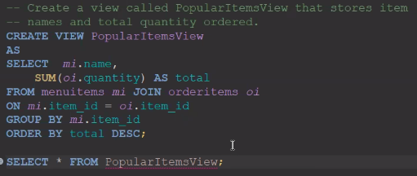

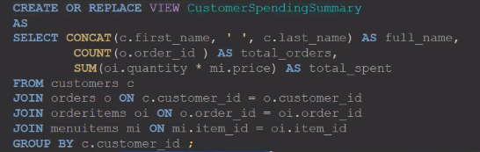

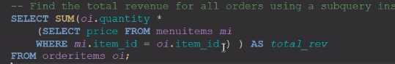

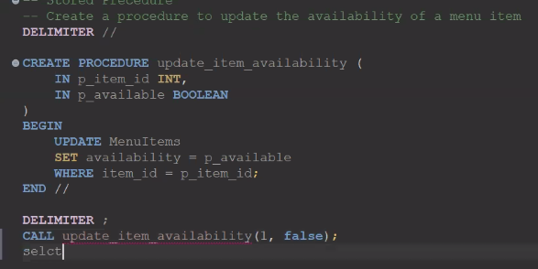

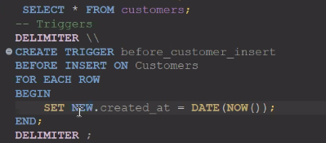

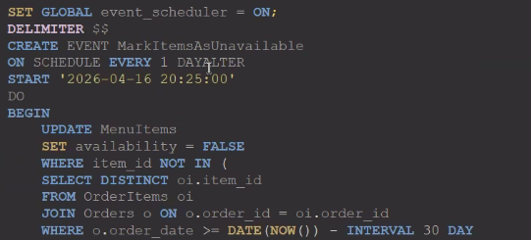

CREATE TABLES IN PYTHON USING VSCODE
import mysql.connector as connector
from config import DB_CONFIG_NO_DB
from library_tables import tables

def create_library_system():

try:

connection = connector.connect(**DB_CONFIG_NO_DB) ## config dictionary name
cursor = connection.cursor()
cursor.execute("CREATE DATABASE IF NOT EXISTS library_1_db;") ## database name
cursor.execute("USE library_1_db;") ## use database
print("Database library1_db has been created.")

## to create tables – tables are created in a FOR loop
## before this create library_tables.py in the form of dictionary

for table, statement in tables.items(): ## KEY, VALUE pair, here VALUE is a statement
cursor.execute(statement) ## execute statement
print(f"Table {table} is created")

## handling exceptions
except connector.Error as err:
print(f'Something went wrong: {err}')

## closing cursor and connection
finally:
if 'cursor' in locals(): ## close cursor - if cursor is open
cursor.close()
if 'connection' in locals(): ##close connection – if connection is open
connection.close()

if __name__ == "__main__":

create_library_system()

INPUT VALUES IN TABLE THROUGH PYTHON

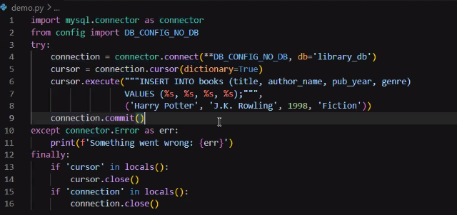

Skeleton of the python file to insert data into table
import mysql.connector
from config import DB_CONFIG_NO_DB

def insert_record(table, data):
db = None
cursor = None
try:
db = mysql.connector.connect(**DB_CONFIG_NO_DB, database="library_db")
cursor = db.cursor()
# Code here

except mysql.connector.Error as err:
print(f"Insertion error: {err}")
finally:
if cursor:
cursor.close()
if db and db.is_connected():
db.close()

if __name__ == "__main__":
book_data = ("The Invisible Man", "H. G. Wells", 1897, "Sci-Fi", True)
#insert_record('books', book_data)
#insert_record('borrowers', ('Sara',))

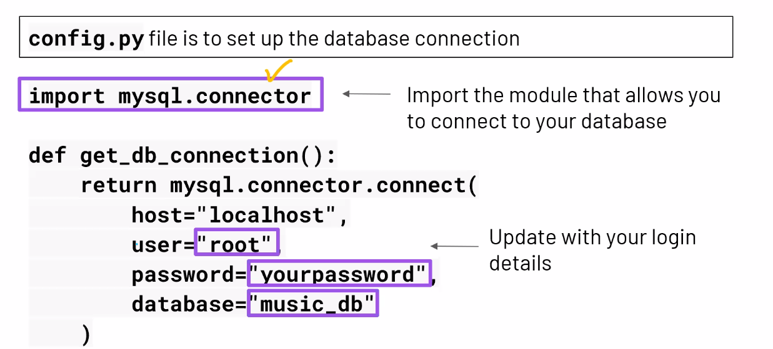

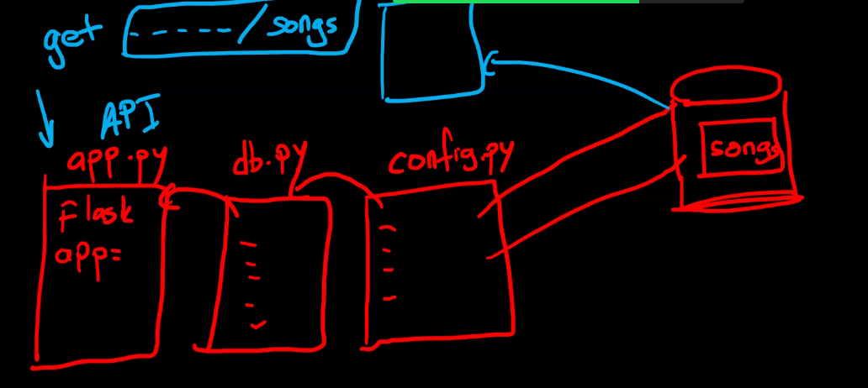

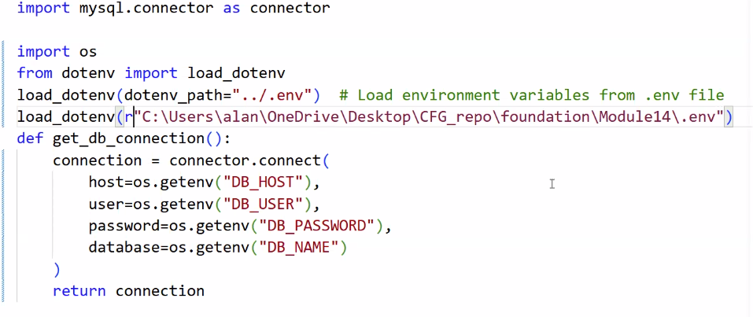
To TEST connection
Print it.
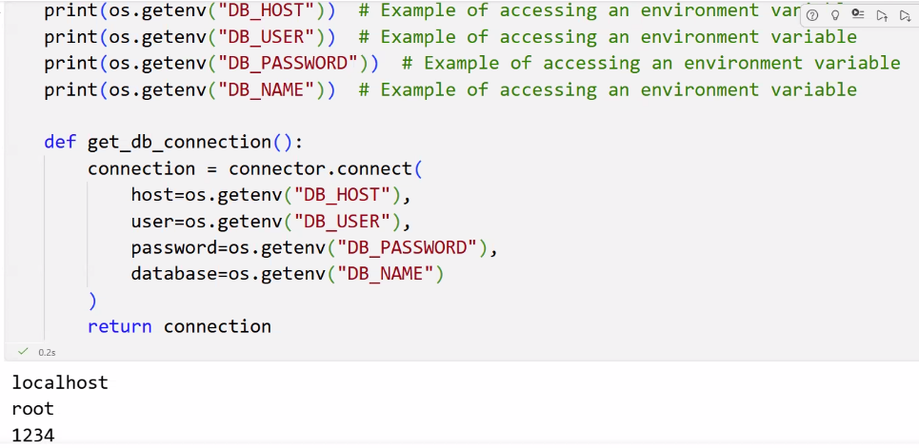
Trouble shooting

To see diagrams
Go to Database navigator
Right-click on database and select ‘View Diagram’

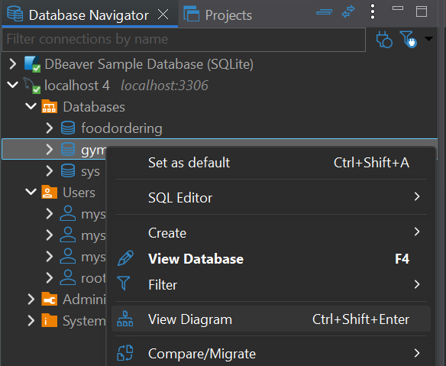
To connect to database
Right-click on connection – create- connect – select database – localhost - finish

To create project
Select projects tab
Select 
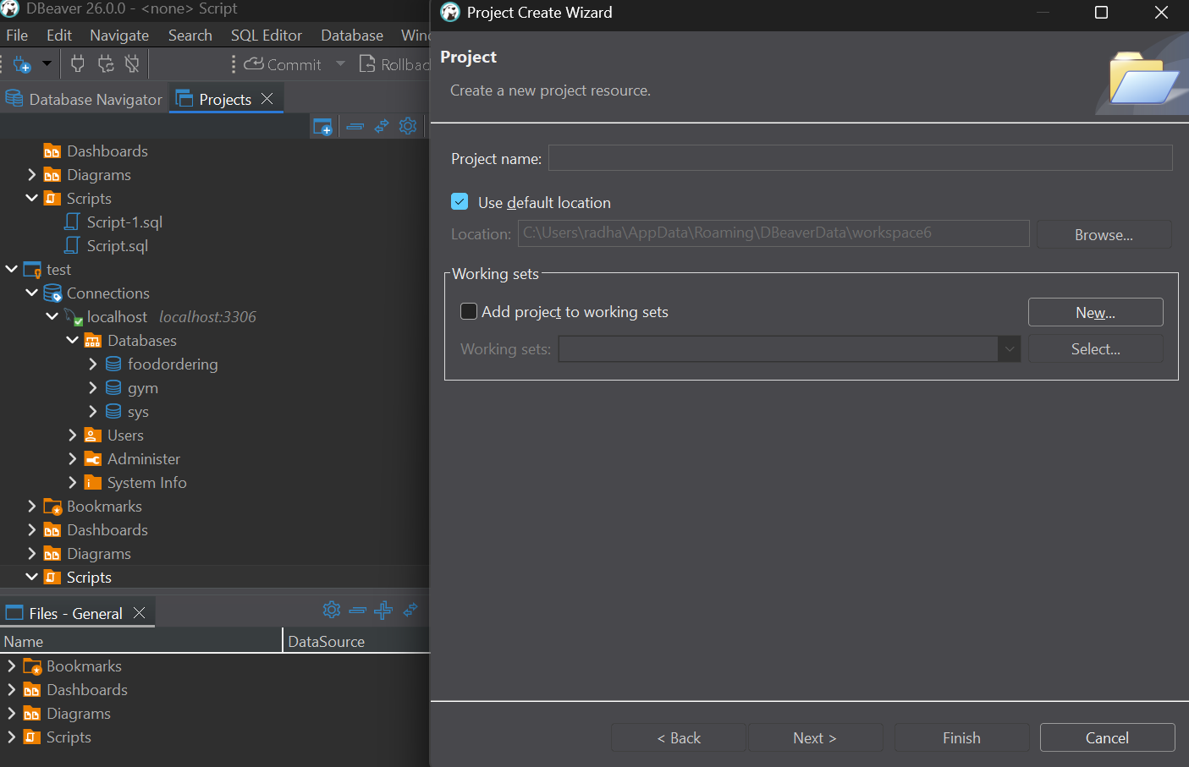
To create script
Right-click on script
Click create
Select ‘Create New file’

Click on 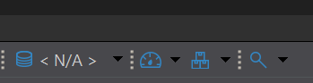
and select ‘localhost’
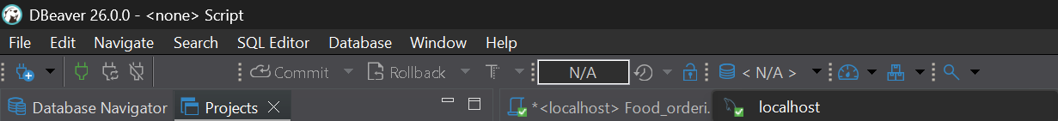

Error when script is un - Public Key Retrieval is not allowed

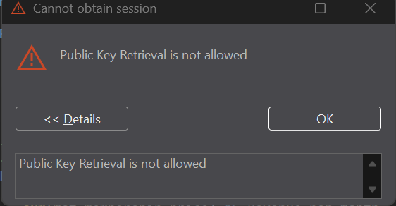

Right clik on the database
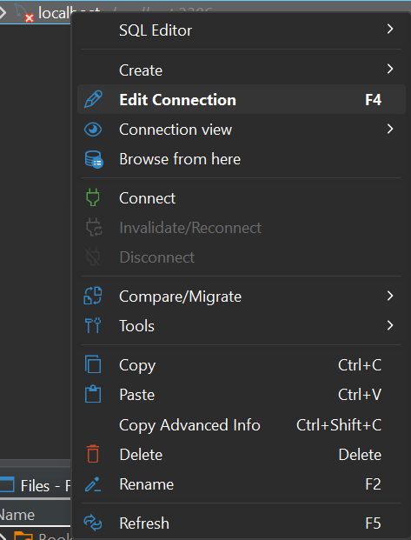
Select ‘Edit connections
Select Driver properties
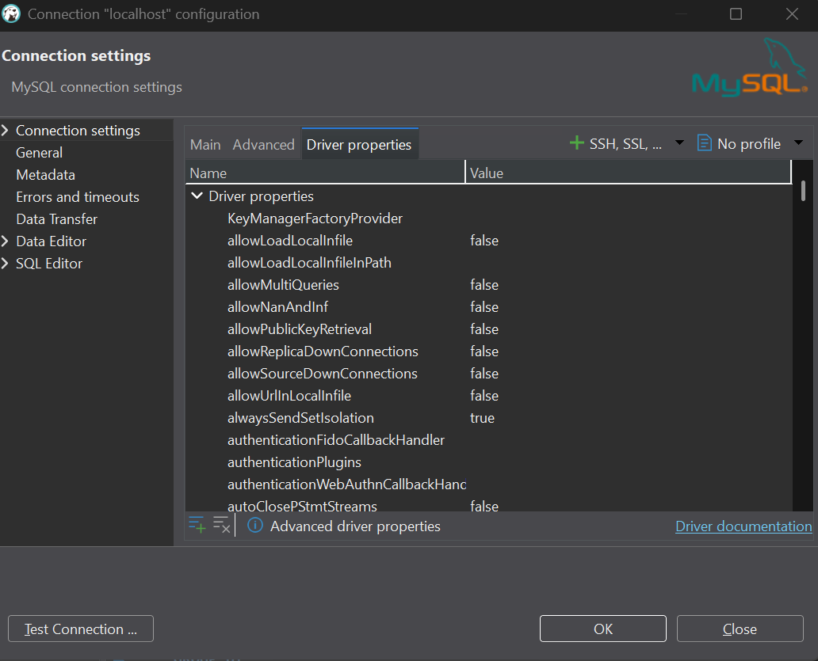

Change ‘allow publicKeyRetrival to ‘TRUE’
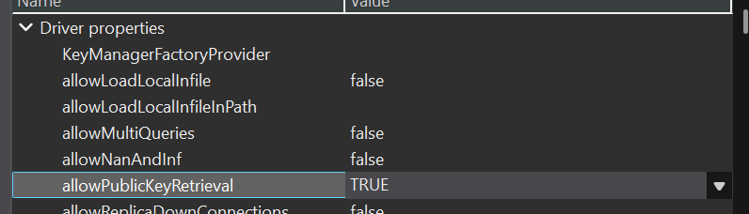

Change ‘useSSL to ‘FALSE

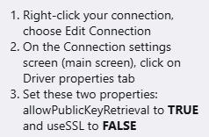

To run procedure or view or trigger or event
Select all the line from delimiter to delimiter and click on ‘execute sql script Alt+X

